# Evaluation Strategy

An evaluation strategy is a plan of action if your client was to implement your solution. The goal is to evaluate the solution.

The strategy should contain:

1. An explanation of the **timeframes** involved
2. A **description** of the criteria that will be used to do the evaluation (efficiency & effectiveness criteria from your SRS)
3. The **users** that might be affected or sampled
4. The **techniques** used to gather the data
5. Which **measure** is being evaluated

The E & E could just be specific measures tested at timed intervals.

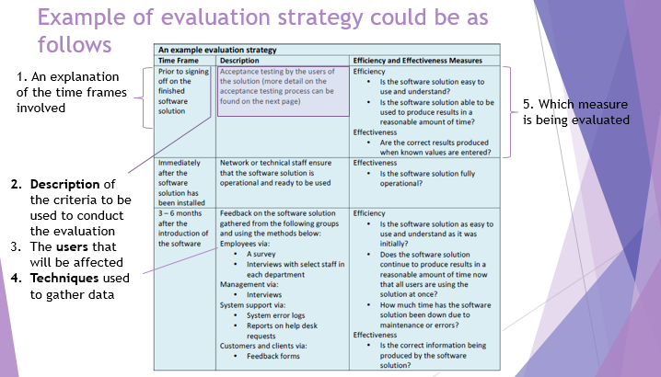

# Requirements evaluation

For the solution requirements you are analysing that the new solution fits with the client’s requirements, both functional and non-functional; this should be taken from your SRS created in SAT part 1. To achieve the highest marks, the high section of the criteria states:

Student evaluation explains in terms of efficiency and effectiveness how specific features of the solution meet all functional and non-functional requirements. Makes reference to a coherent and comprehensive set of criteria.

You should list out which efficiency and effectiveness criteria meet the FR and NFR and screenshot aspects of your solution to state which aspect met these criteria.

For example:

## Functional Requirements

|  |  |  |  |
| --- | --- | --- | --- |
| No. | Requirement | Notes | How requirement has been met: |
| FR01 | Able to add new customer | This function will be used by the client to enter new clients | A **screenshot** of the add client form would go here, then a little description: customer added to file easily |

## Non-Functional Requirements:

|  |  |  |  |
| --- | --- | --- | --- |
| No. | Requirement | Notes | How requirement has been met: |
| NFR01 | Maintainability (effectiveness can **sometimes** relate to NFR): the software must contain relevant comments | This will allow modifications to be implemented improving reliability and maintainability of the solution | A **screenshot** of code with relevant comments could go here, then a little description: all code has been commented in accordance with programming practice. |

**Efficiency** is a **measure** of how much **time**, **cost** and **effort** is applied to achieve intended results.

* Measures of efficiency in a **solution** could include the **speed of processing**, its **functionality** and the **cost of file manipulation**.

**Effectiveness** is a **measure** of how well a **solution**, an information management strategy or a network work, and whether each achieves its intended results.

* **Measures** of effectiveness in a **solution** include **c**ompleteness, **a**ttractiveness, **r**eadability, **a**ccuracy, **t**imeliness, **a**ccessibility, **c**larity, and **c**ommunication of message, **r**elevance and **u**sability. (**CARATACCRU)**

**Functional Requirements**

* What is the system required to do?

**Non Functional Requirements**

* Describes the **attributes** the solution should possess - Usability, reliability, portability, robustness, maintainability